Maybe you have learned about American Sign Language in school. But did you know that two thirds of the Native American people used a similar Sign Language to communicate with one another? There are over 400 different Native American languages spoken and American Indian Sign Language was a way that they could all communicate and understand each other. It is one of, if not the oldest, universal sign language of any kind.
In the story “How Rabbit Got His Long Ears” one of the ways that his forest friends could have communicated better with him is if they used Sign Language. Someday you might meet someone like Rabbit who does not hear very well, wouldn’t it be nice if you had a way to talk to them and include them in on the fun things that you are doing with your friends? Look at the American Sign Language chart below and see if you can spell out your name using Sign Language, it just might come in handy one day if you need to introduce yourself to someone who can’t hear very well.

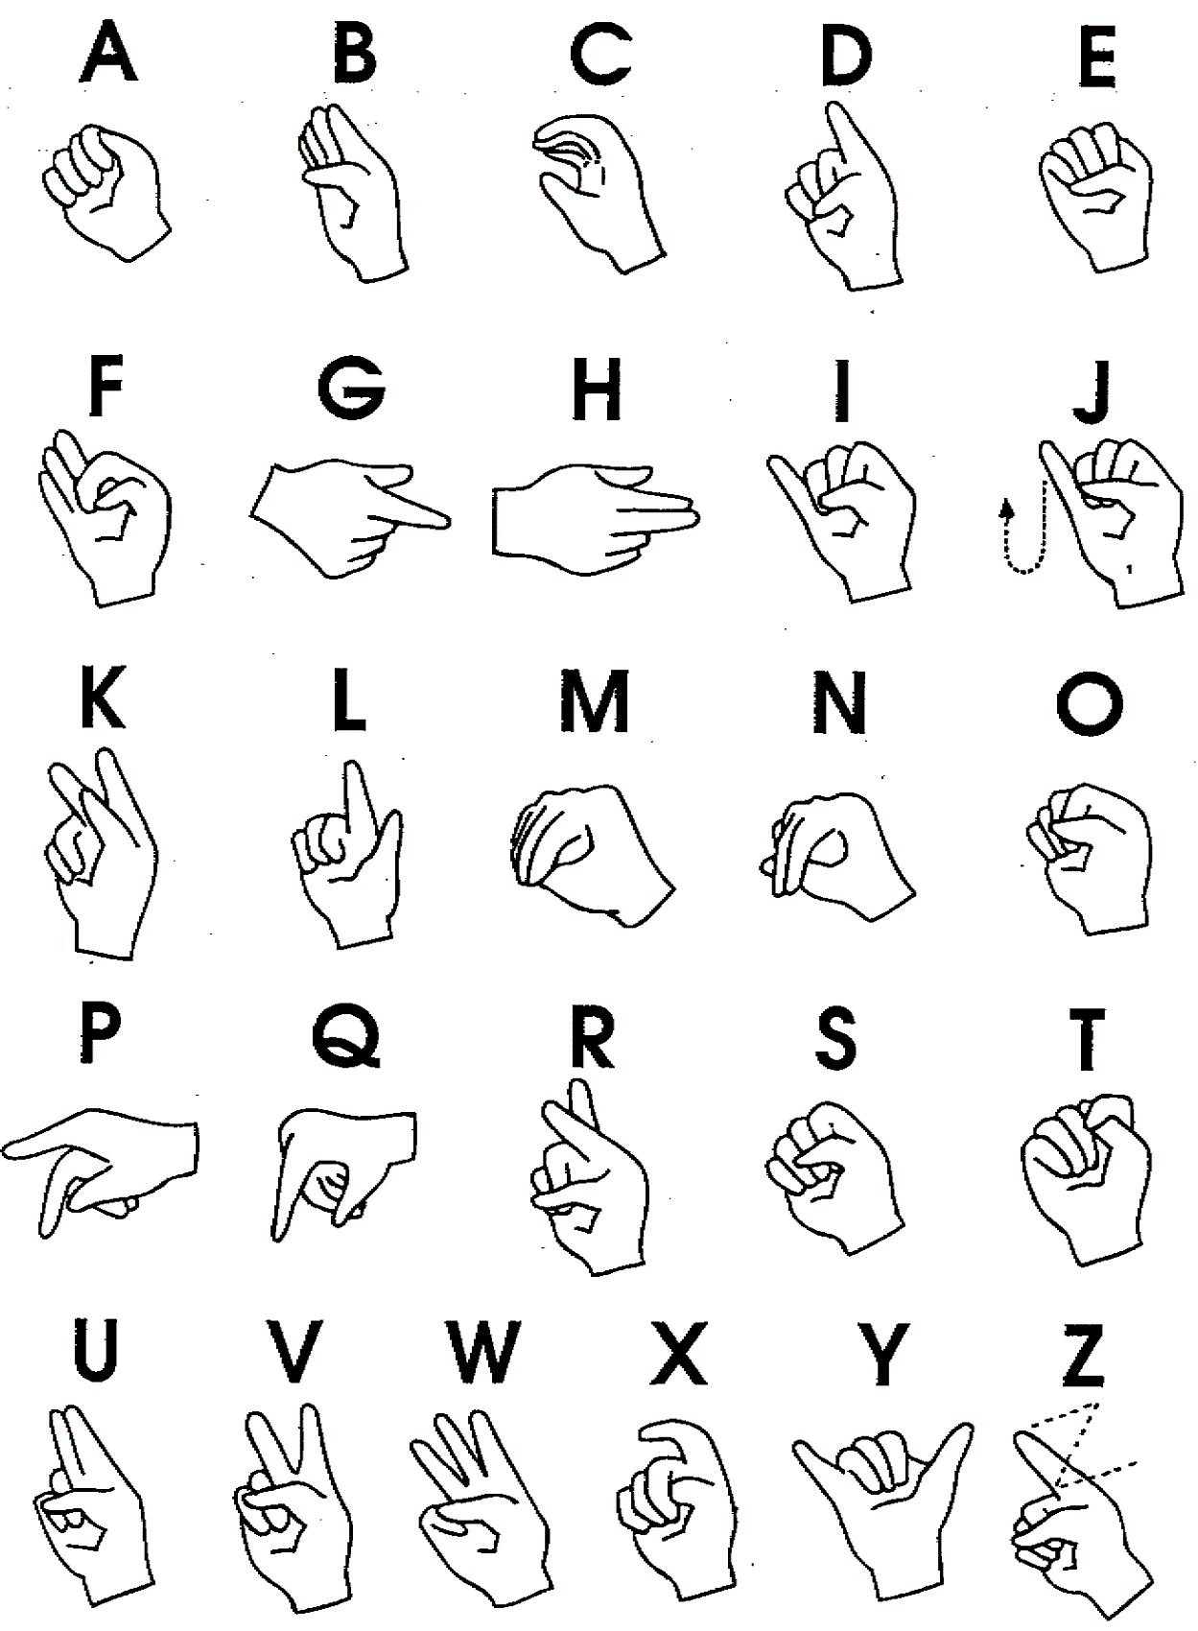
If you would like to learn how to say phrases, click on this link:
http://www.lifeprint.com/asl101/index/sign-language-phrases.htm

