Let’s Learn About Rabbits
There are many stories and cartoons about rabbits. Quick! Name all of the famous rabbits that you know from stories, cartoons and books. You probably came up with quite a few! But how much do you know about rabbits in the wild? Let’s learn more about the different types of rabbits, their habitat, diet, and other special physical features that help them survive in the wild.

Types of Rabbits
Rabbits are mammals, which means they are warm-blooded, have backbones and hair. There are around thirty different species of wild rabbits, and they can weigh anywhere from less than a pound to over four pounds. These furry creatures can be found all over the world. Perhaps you have seen one of the most common types, the Eastern Cottontail. These wild animals have a white tail that looks exactly like a cotton ball!

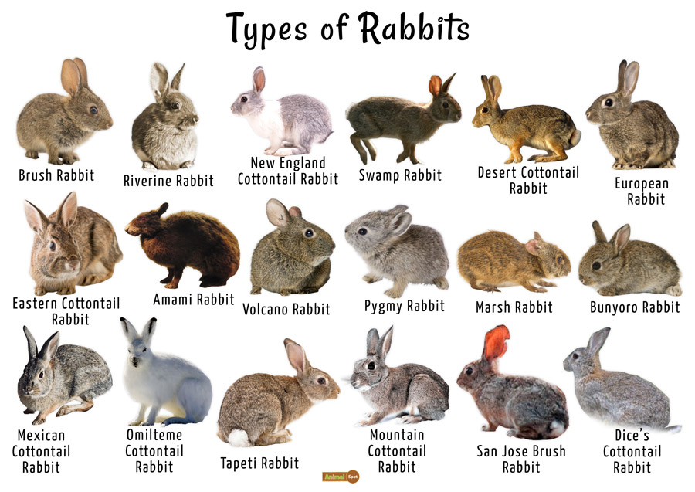
Courtesy of : https://www.animalspot.net/rabbit

Habitat and Diet
Rabbits like to live in groups, and they can be found in grasslands, forests, meadows, and even deserts! Some rabbits like to create burrows or dig holes and tunnels in the ground. This is where they often give birth to their young. Males are called bucks, and females are referred to as does.
Rabbits are herbivores, which means they eat only plants. You can try giving a rabbit some carrots, since this is common in cartoons. However, a wild rabbit would probably prefer grasses or leaves for lunch. If you have a backyard, you may notice around dusk a rabbit nibbling on grass if the environment is quiet.
Rabbit holes are burrows that create tunnels underground for rabbits to find shelter

Physical Characteristics
Rabbits have special body features to help them survive in the wild. They have sharp long claws, which help them dig their burrows for protection. Their long ears are not only cute, but they provide sensitive hearing which can help them locate predators. Other than the white cottontail, rabbits have coloring that blends in easily with their surroundings. This helps them to disappear into the environment and escape the gaze of predators. And if all of those adaptions fail, they have strong hind feet that can help them run quickly to safety!
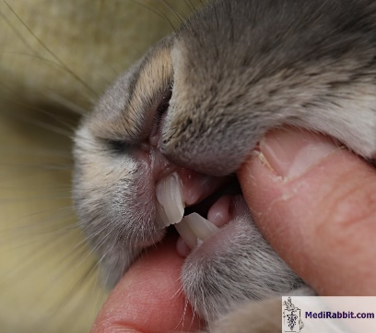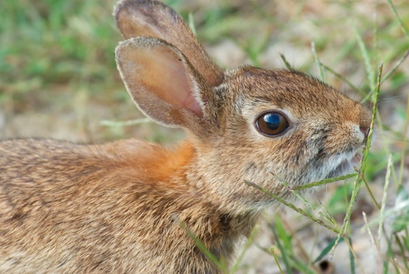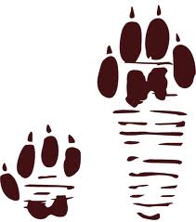
Courtesy of: https://study.com/academy/lesson/rabbit-facts-lesson-for-kids.html
Rabbits: Quiz

- What type of animal is a rabbit?

  - Reptile
  - Bird
  - Mammal

- What is the most common rabbit?

  - Snowshoe hare
  - Cottontail rabbit
  - Long-eared rabbit

- What is a burrow?

  - A rabbit hole or tunnel
  - A type of rabbit
  - Rabbit food

- What is an herbivore?

  - Animals with bones
  - Plant eaters
  - Meat eaters

- What special characteristic does a rabbit have?

  - A loud bark
  - It can climb tree
  - It has long ears

- Why do rabbits have long back legs?

  - For swimming
  - To help them run fast
  - So they can scratch their ears

See next page for answers:
Answers: 1.c, 2. b, 3.a, 4.b, 5.c. 6. b

