Popsicle Stick Catapult
Adult supervision is recommended

Levers might seem simple, but they are a powerful technology. An atlatl can launch a dart with more than 4 times the force of a human arm. A catapult is another powerful tool that uses a lever, or fulcrum. You may have seen catapults in movies or history books. They were used in medieval times during battles to knock down castle walls. Follow these instructions to make your very own (miniature) catapult at home! These instructions were adapted from the website Little Bins for Little Hands, where you can find more exciting science activities (https://littlebinsforlittlehands.com/).

Supplies Needed:

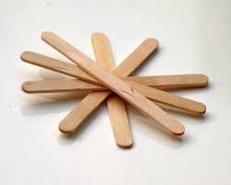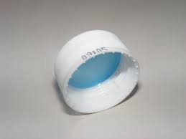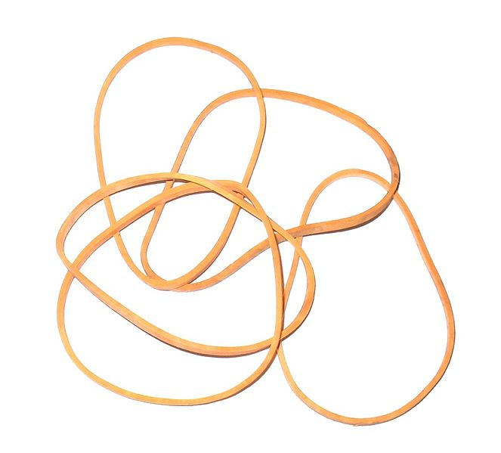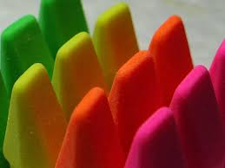

10 Popsicle Sticks Bottle Cap Rubber Bands “Payload” (erasers, marshmallows, etc)

(Note: if you do not have popsicle sticks, you can also use legos, pencils, or spoons to build your catapult.)

Step 1: Gather all of the supplies and read through the directions.

Step 2: Using a pair of scissors, make a small V-shaped notch on either side of the popsicle stick, about a half-inch from the end of the stick. Do this for 2 of the popsicle sticks. See photo below:
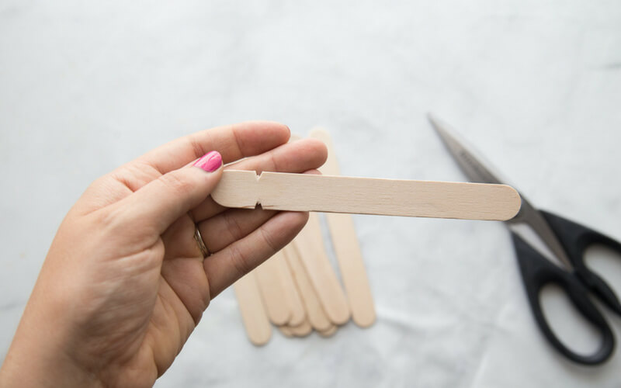
(Photo courtesy: Little Bins for Little Hands)

Step 3: Take 8 popsicle sticks and stack them on top of each other. Wrap rubber bands tightly around both ends of the popsicle stick stack.

Step 4: Push one of the notched popsicle sticks through the stack. It should go underneath the top stick of the stack. If you have done it correctly, you will have made a plus sign with the sticks. Again, check out the photo below, courtesy of Little Bins for Little Hands:

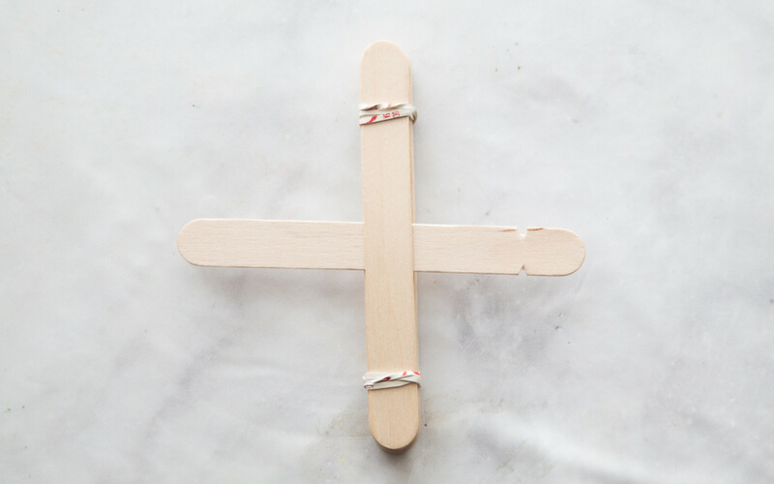
(Photo courtesy: Little Bins for Little Hands)

Step 5: Now, flip the plus sign over. The stick with the V-notches should be on the bottom.

Step 6: Lay the remaining V-notched popsicle stick on top of the stack in the same direction as the V-notched stick on the bottom. Use rubber bands to tightly tie the two V-notched popsicle sticks together. Give yourself a pat on the back if it looks like this:

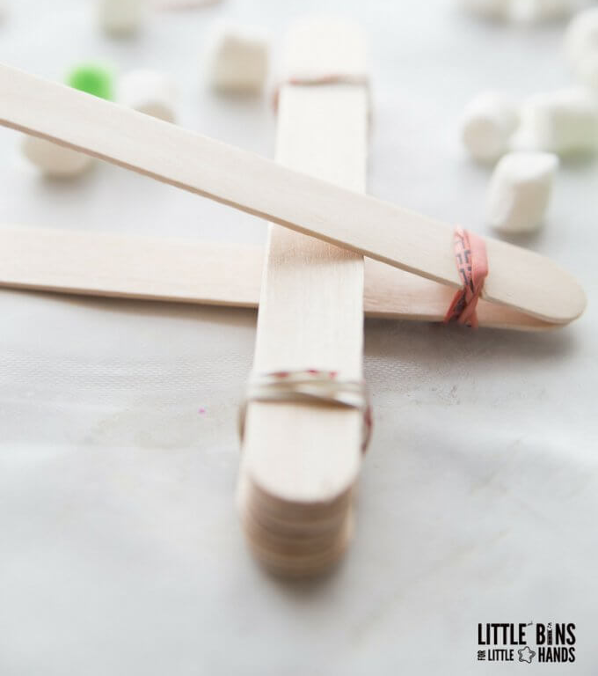
(Photo courtesy: Little Bins for Little Hands)

Step 7: Glue a bottle cap onto the high end of the catapult lever. You can try shooting marshmallows, erasers, or cotton balls, but please don’t launch sharp objects. Also, even if you think an object is soft, please don’t shoot it at people or pets.

Catapult Challenges:
- Have multiple people in your family build one. See who can get their items to go the furthest.
- Stack paper cups or other items and see if you can knock them down.
- Try different types of items and see if certain items go further than others.

