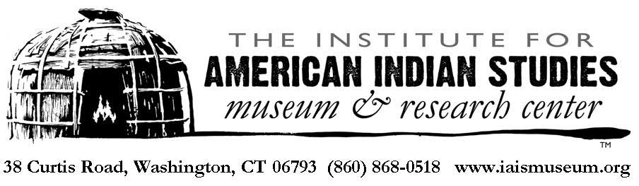

The staff and trustees of the Institute for American Indian Studies thank you for your support over the past several months. Beginning Friday, May 22, we will be opening a redeveloped outdoor museum experience. Included in admission, our staff has developed safe and educational opportunities for you and your family, that you can experience on our grounds. For the time being, the following educational opportunities will be offered on Fridays, Saturdays and Sundays.
Visit our newly rebuilt 16th century replica Algonkian Village to hear about Native American community life prior to European contact. Learn about food sustainability and natural healing methods in our Three Sisters and Medicinal Plant Gardens. Enjoy educational scavenger hunts along our woodland trails and stop in at our Archaeology Pavilion as we show how museums like ours learn from the past.
Even as we welcome you back to our Outside Museum and encourage you to engage with the more than 10,000 years of Native American history, the safety of our visitors, members and staff is a priority. Please review our safety policies below. Thank you once again for your support and understanding as we further develop the Outside Museum concept and begin the transition towards reopening our Native American Museum.

In accordance with Reopening CT guidelines, we will have safety measures in place to promote social distancing and best practices:

- Our indoor exhibits will remain closed during Phase 1 of reopening. We anticipate being able to open the indoor exhibits with modifications and enhanced cleaning procedures during Phase 2. Please check back for details.
- Through an abundance of caution, we have limited the capacity on our grounds to 35. If we exceed capacity we will encourage visitors to wait near their cars, visit Washington Depot, or visit nearby Steep Rock Preserve.
- To ensure proper cleaning and allow for setup of educational activities, we will have reduced hours. The Outdoor Museum will be open on Fridays and Saturdays from 11:00am to 4:00pm, and on Sundays from noon to 4:00pm.
- All staff who interact with visitors will be wearing masks. We encourage visitors to bring masks, as well.
- Staff and signage will direct visitors as to the appropriate traffic flow, so that everyone can enjoy the educational experiences safely and at their own pace.
- Please be aware of your surroundings and respect other peoples’ social distance.

